Agribot – Pesticide Spraying Robot
PROJECT REPORT
Submitted by

ISHANI (RA2311032010001)

NISHKA ARORA (RA2311032010019)

KARAN PAMNANI (RA2311032010035)

SAMARTH ALHAWAT (RA2311032010038)

Under the Guidance of

Dr. Ramya G
21CSE305P – SerBot: Project-Based Learning in Robotics

DEPARTMENT OF NETWORKING AND COMMUNICATIONS



FACULTY OF ENGINEERING AND TECHNOLOGY
SCHOOL OF COMPUTING
SRM INSTITUTE OF SCIENCE AND TECHNOLOGY

KATTANKULATHUR
NOVEMBER 2025


SRM INSTITUTE OF SCIENCE AND TECHNOLOGY
KATTANKULATHUR -603203
(Under Section 3 of UGC Act, 1956)

BONAFIDE CERTIFICATE

Certified that the 21CSE305P – SerBot: Project-Based Learning in Robotics course project report titled “Agribot-Pesticide Spraying Robot” is the bonafide work done by ISHANI (RA2311032010001), NISHKA ARORA (RA2311032010019), KARAN PAMNANI (RA2311032010035), SAMARTH ALHAWAT (RA2311032010038) of III Year / V Sem B.Tech (CSE-INTERNET OF THINGS) who carried out the project under my supervision.

SIGNATURE  Faculty In-Charge  Dr. Ramya G  Associate Professor,  Department of Networking and Communications,  SRM Institute of Science and Technology Kattankulathur | SIGNATURE  Head of the Department  Dr.Lakshmi M  Professor and Head  Department of Networking and Communications,  SRM Institute of Science and Technology Kattankulathur

ABSTRACT

The Agribot – Pesticide Spraying Robot is an innovative IoT-enabled agricultural automation system developed to ensure safe, efficient, and uniform pesticide application while reducing farmers’ exposure to harmful chemicals. Traditional spraying methods expose farmers to toxic substances and involve significant physical effort. The proposed system uses an ESP8266-based robotic platform that can be operated remotely via the Blynk IoT mobile application, allowing wireless control of movement and spraying operations.The robot is equipped with BO motors for motion, a DC pump for spraying, servo motors for nozzle control, and a relay for automation. Additionally, an HC-SR04 ultrasonic sensor is integrated to detect obstacles and prevent collisions, ensuring smooth and safe navigation during operation. A rechargeable battery powers the entire system, making it portable and suitable for small and medium-scale farms.This design provides a cost-effective, farmer-friendly, and scalable solution for pesticide application. It not only minimizes direct exposure to harmful chemicals but also improves spraying efficiency and field safety. The Agribot demonstrates strong potential for future upgrades with additional sensors, GPS integration, and AI-based precision spraying for smarter agricultural practices.

ACKNOWLEDGEMENT

We express our heartfelt thanks to our honourable Vice Chancellor Dr. C. MUTHAMIZHCHELVAN, for being the beacon in all our endeavours. We would like to express my warmth of gratitude to our Registrar Dr. S Ponnusamy, for his encouragement.

We express our profound gratitude to our Dean (CET) Dr. Leenus Jesu Martin M, for bringing out novelty in all executions. We would like to express my heartfelt thanks to Chairperson, School of Computing Dr. Revathi Venkataraman, for imparting confidence to complete my course project. We would like to express my thanks to Associate Chairperson, School of Computing Dr. Pushpalatha M, for complete of my course project.

We extend my gratitude to our HOD Dr. Lakshmi M, Professor and Head, Department of Networking and Communications and Departmental colleagues for their Support.

We wish to express my sincere thanks to Course Audit Professors Dr.P.Prakash, Professor, Department of Data Science and Business Systems and Course Coordinator for their constant encouragement and support.

We are highly thankful to our Course project Faculty Dr. Ramya G, Associate Professor, Department of Networking and Communications, for her assistance, timely suggestion and guidance throughout the duration of this course project.

Finally, we thank our parents and friends near and dear ones who directly and indirectly contributed to the successful completion of our project. Above all, I thank the almighty for showering his blessings on me to complete my Course project.

TABLE OF CONTENTS

Sl. No. | Title | Page No.
1. | Introduction | 6
2. | Literature Survey | 7
3. | Requirement Analysis  3.1 Currently Existing  3.2 Project Requirements | 9
4. | Architecture and Design  4.1 Architechture,  4.2 Module Explanation,  4.3 Working Principle | 12
5. | Implementation  5.1 Hardware Implementation  5.2 Software Implementation  5.3 Communication Setup | 17
6. | Experiment Result and Analysis | 27
7. | Conclusion | 29
8. | Future Scope | 30
9. | References | 31

CHAPTER 1
INTRODUCTION

Agriculture is vital for sustaining human life and supporting national economies, especially in developing countries like India, where many depend on farming for their livelihood. Despite progress, several farming tasks—particularly pesticide spraying—are still performed manually, exposing farmers to toxic chemicals that cause serious health issues. Manual spraying is also time-consuming, labor-intensive, and leads to uneven coverage and chemical wastage.

To overcome these issues, automation and IoT-based technologies are being adopted to enhance safety and efficiency. The Agribot – Pesticide Spraying Robot provides a semi-automated, remotely controlled spraying solution that minimizes human exposure and improves precision. Using an ESP8266 NodeMCU microcontroller connected to the Blynk IoT app, farmers can wirelessly control the robot’s movement and spraying through Wi-Fi, ensuring convenience and ease of operation.

The robot uses BO motors for motion, an L298N motor driver for control, servo motors for nozzle adjustment, and a DC pump for pesticide dispensing. An HC-SR04 ultrasonic sensor detects obstacles, while a rechargeable battery powers the system. The robot’s advantages include low cost, uniform spraying, reduced chemical wastage, and improved safety. However, limitations such as dependence on Wi-Fi connectivity, limited battery life, and reduced performance on uneven terrains affect its efficiency.

Overall, the Agribot successfully integrates IoT, embedded systems, and robotics to offer a smart, affordable, and practical solution for safer and more sustainable farming.

CHAPTER 2

LITERATURE SURVEY

Recent advancements in agricultural robotics and IoT systems focus on improving spraying precision, reducing farmers’ exposure to toxic chemicals, and lowering costs for small-scale farms. Studies show a shift from manual or remote-controlled sprayers to intelligent, sensor-based systems capable of selective spraying. IoT-enabled robots using low-cost microcontrollers like Arduino or ESP8266 with Blynk apps provide real-time control and affordable automation. Hybrid models allow semi-autonomous operation, balancing simplicity and efficiency. While advanced AI-based systems offer targeted spraying, they remain expensive for smallholders. Overall, research highlights that IoT-based pesticide spraying robots enhance safety, efficiency, and cost-effectiveness—aligning well with the goals of the Agribot Pesticide Spraying Robot.

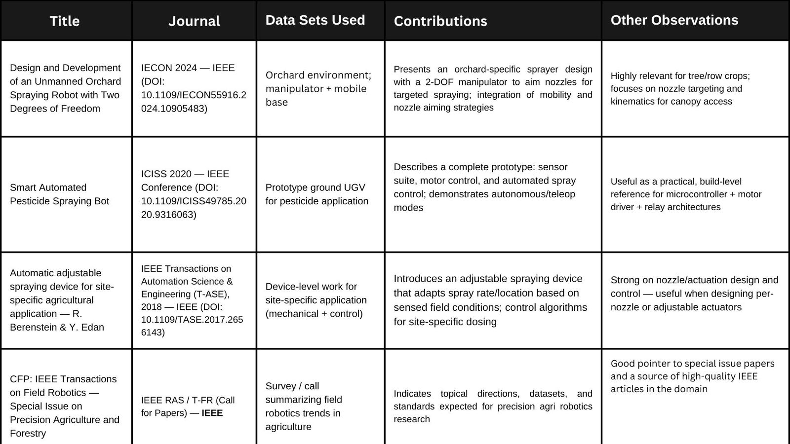

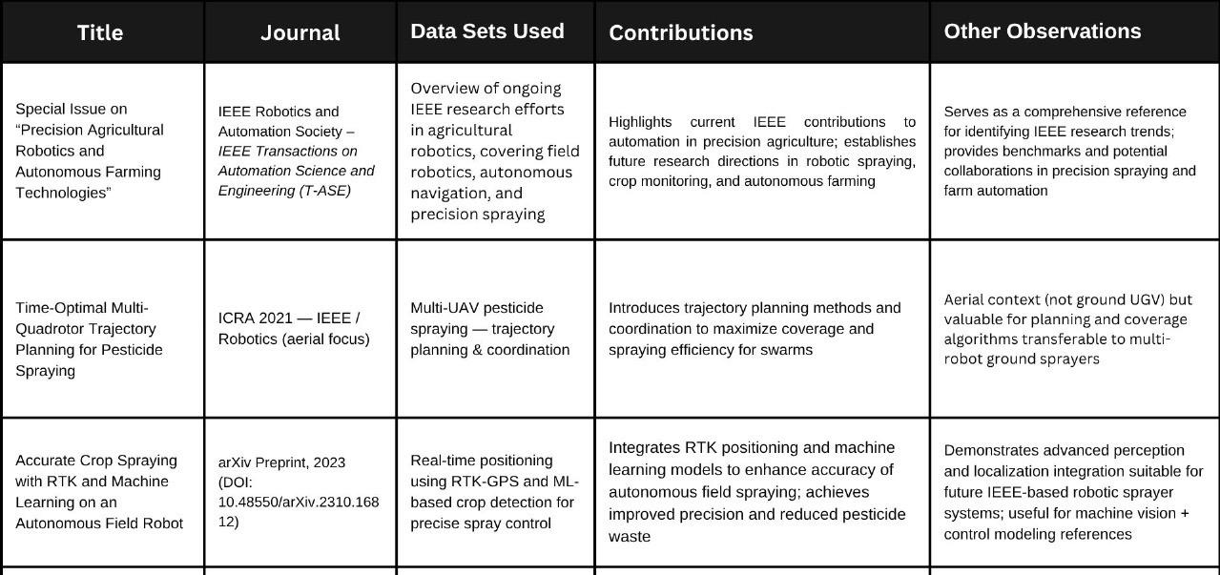

CHAPTER 3
REQUIREMENT ANALYSIS

Requirement analysis is a vital stage in the design and development of any project, as it defines the system’s needs, objectives, and constraints. It helps in understanding what the system must accomplish, what resources are necessary, and how the proposed solution improves upon existing methods. For the Agribot – Pesticide Spraying Robot, requirement analysis ensures that both hardware and software components work together effectively to achieve automation, safety, and efficiency in pesticide spraying operations.

3.1 CURRENTLY EXISTING

The existing pesticide spraying process in agriculture is predominantly manual. Farmers carry heavy pesticide tanks on their backs and use handheld sprayers to cover fields. This method is physically demanding, time-consuming, and poses significant health hazards due to direct exposure to harmful chemicals. Manual spraying often results in uneven pesticide distribution, leading to wastage, lower crop quality, and potential environmental contamination. Additionally, small and medium-scale farmers lack affordable automation alternatives, forcing them to rely on unsafe and inefficient traditional techniques.

3.2 PROJECT REQUIREMENTS

The proposed system aims to develop an IoT-based, Wi-Fi-controlled robot that automates pesticide spraying and minimizes direct farmer exposure. The project requires an efficient integration of mechanical, electronic, and software components to enable remote operation, mobility, and spraying control. The robot should be lightweight, portable, energy-efficient, and affordable, making it practical for field use. It must ensure smooth movement across crop rows, uniform spraying through a controlled nozzle system, and reliable connectivity between the mobile application and the hardware unit.

3.2.1. Functional Requirements:

• The robot should move forward, backward, left, and right through wireless commands.
• It must spray pesticide when the farmer activates the pump through the mobile application.
• The nozzle direction should be adjustable using servo motors for uniform coverage.
• The system should be capable of continuous operation for a reasonable duration using rechargeable power.
• The mobile interface (Blynk app) should establish a stable Wi-Fi connection with the ESP8266 microcontroller.
• The robot should maintain consistent spraying pressure and flow during operation.

3.2.2 Non-Functional Requirements:

• The system should be user-friendly and require minimal technical knowledge for operation.
• It must be reliable and capable of functioning under typical field conditions such as dust and mild uneven terrain. .
•The components should be cost-effective and easily replaceable. .
•The design should ensure portability and low maintenance requirements. .
•The communication between hardware and mobile application should be stable and responsive with minimal delay. .
• The system should consume low power and provide adequate battery backup for field use.

3.2.3 Hardware Requirements

•ESP8266 NodeMCU – microcontroller with inbuilt Wi-Fi for wireless communication and control.
•L298N Motor Driver – used for driving the BO motors and managing robot movement.
•BO Motors (2 or 4 units) – provide motion capability for forward, reverse, and directional turns.
•SG90 Servo Motors (2 units) – control the direction and angle of the pesticide nozzles.
•Mini Submersible DC Pump (3–6V) – sprays pesticide through connected tubing.
•Relay Module (5V) – switches the pump on and off according to commands.
•18650 Rechargeable Battery with Holder (7.4V) – serves as the power source for the system.

•Plastic Bottle – used as the pesticide tank.
•Robot Chassis Kit (2WD/4WD) – base platform to mount all components securely.
•Mini Toggle Power Switch – for controlling the power supply.

• HC-SR04 Ultrasonic Sensor – used for obstacle detection and avoidance by measuring the distance between the robot and nearby objects.

3.2.4. Software Requirements

• Arduino IDE – used for writing, compiling, and uploading control programs to the ESP8266 microcontroller.
• Blynk IoT Application – provides a smartphone interface for wireless control of the robot’s movement and spraying functions. .
• Wi-Fi Network – required for communication between the mobile device and the robot.

CHAPTER 4

ARCHITECTURE AND DESIGN

The architecture and design of the Agribot – Pesticide Spraying Robot integrate hardware and software components to enable smooth and automated spraying. The ESP8266 NodeMCU serves as the main controller, receiving commands from the Blynk IoT app via Wi-Fi to control the robot’s movement and spraying functions. The motor driver manages motion, the relay controls the pump, and servo motors adjust the spray nozzles for uniform coverage. All components are mounted on a compact chassis powered by rechargeable batteries. The design ensures efficient operation, easy maintenance, and reliable wireless control for safe and effective pesticide application.

4.1 Architecture:

The architecture of the Agribot – Pesticide Spraying Robot integrates mechanical, electronic, and communication components into a single automated system for safe and efficient pesticide application. It consists of six main modules: the control module, motion module, spraying module, servo control module, obstacle detection module and power supply module. The ESP8266 NodeMCU microcontroller serves as the central control unit, receiving commands from the Blynk IoT mobile application via Wi-Fi and executing them to control various components.

When a command is sent from the smartphone, the ESP8266 processes it and signals the motor driver (L298N) to operate the BO motors for movement in different directions. The relay module controls the DC pump that sprays pesticide from the tank, while servo motors adjust the spray nozzle’s direction for uniform coverage. A rechargeable 7.4V battery powers the entire system, ensuring smooth operation in the field. The architecture also includes an HC-SR04 ultrasonic sensor connected to the ESP8266 for detecting obstacles ahead of the robot, allowing it to operate safely in the field and avoid collisions during movement.

Real-time wireless communication between the Blynk app and the ESP8266 enables easy control without wired connections. The modular and portable design ensures reliability and scalability, making Agribot an efficient, low-cost solution for small and medium-scale farms seeking automation in pesticide spraying.

4.1.1 Architecture Diagram

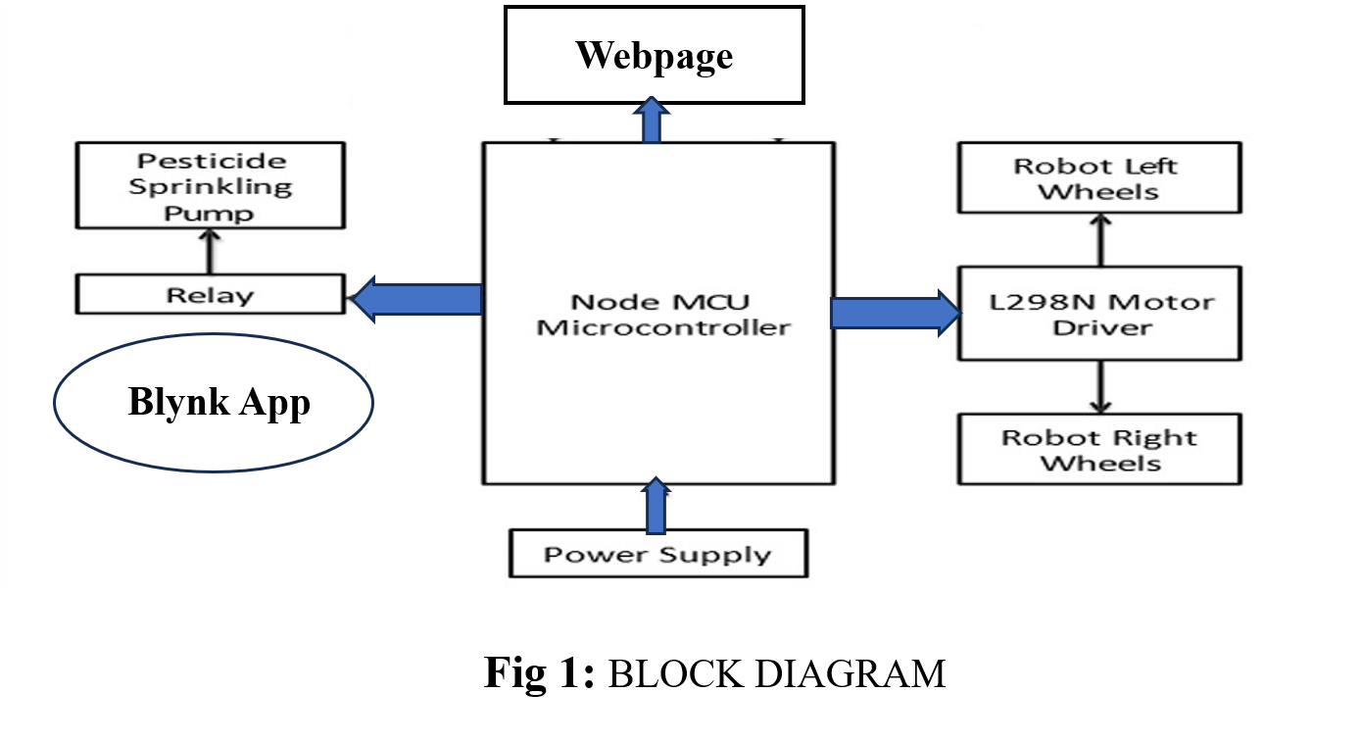

4.1.2 Circuit Diagram

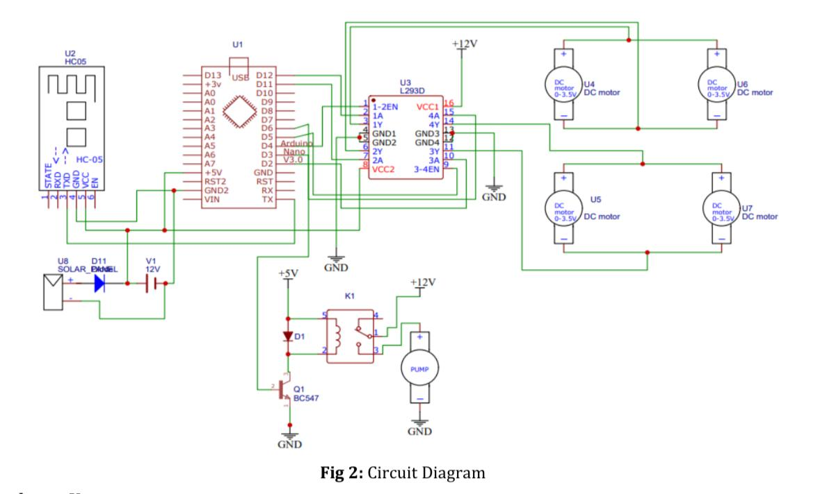

4.1.3 UML Diagram

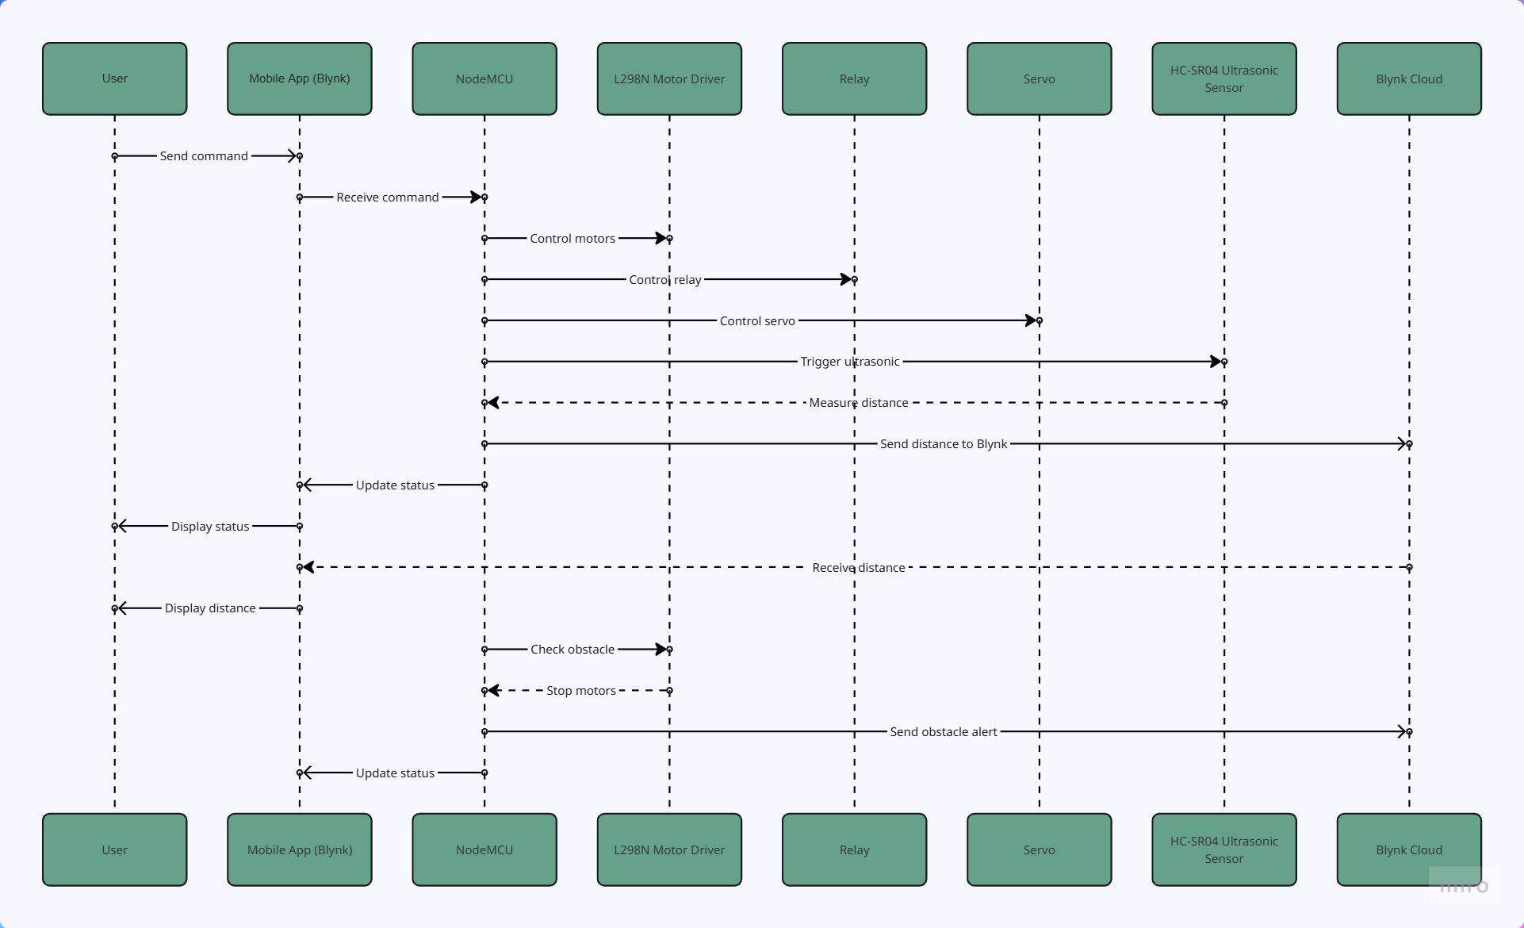

4.1.4 Use Case Diagram

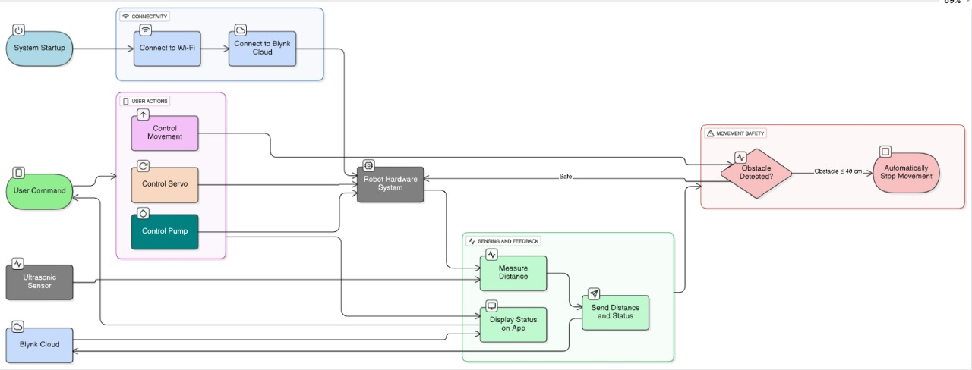

4.2 Module Explanation

The Agribot – Pesticide Spraying Robot is composed of several key modules that work together to perform spraying operations efficiently and safely.

• Control Module: The ESP8266 NodeMCU microcontroller acts as the main controller, receiving commands from the Blynk IoT app via Wi-Fi and coordinating all operations.

• Motion Control Module: Consists of BO motors and an L298N motor driver that control the robot’s movement in forward, backward, left, and right directions based on user input.

• Spraying Module: Includes a DC pump connected through a relay module, which sprays pesticide from the tank when activated from the mobile application.

• Servo Control Module: Uses SG90 servo motors to adjust the direction and angle of the spray nozzles, ensuring uniform pesticide distribution.

• Power Supply Module: A 7.4V rechargeable battery powers all components, providing stable and continuous operation during field use.

• Obstacle Detection Module: The obstacle detection module uses an HC-SR04 ultrasonic sensor connected to the ESP8266 to measure the distance between the robot and nearby objects. It emits ultrasonic waves and calculates the time taken for the echo to return, helping the robot detect obstacles in its path. If an object is too close, the robot can automatically stop or alert the user through the mobile app, ensuring safe navigation during spraying.

Each module functions in coordination with the control unit, creating a compact and reliable IoT-based system for automated pesticide spraying.

4.3 Working Principle

The working of the Agribot – Pesticide Spraying Robot is based on IoT-enabled wireless control and automation. The following points describe the step-by-step working principle of the system:

• When the system is powered on, the ESP8266 NodeMCU microcontroller initializes and connects to the configured Wi-Fi network.

• The Blynk IoT mobile application serves as the control interface, allowing the farmer to send commands wirelessly to the robot.

• The ESP8266 receives these commands in real time and processes them to control the respective modules.

• The L298N motor driver receives control signals from the microcontroller and drives the BO motors to move the robot forward, backward, left, or right according to user input.

• When the user presses the spray command in the Blynk app, the microcontroller sends a signal to the relay module, which activates the DC pump.

• The pump draws pesticide from the attached tank and sprays it through connected nozzles.

• The servo motors adjust the nozzle’s direction and angle to ensure uniform pesticide coverage across the crop area.

• The spraying continues until the user deactivates the pump from the mobile application, at which point the relay turns off the pump.

• The HC-SR04 ultrasonic sensor continuously measures the distance from obstacles in the robot’s path. If any object is detected within a predefined range, the robot stops or notifies the user through the Blynk app to prevent collision.

• Throughout operation, all commands are executed wirelessly in real time, with minimal delay, ensuring smooth control and efficient spraying.

• The rechargeable battery provides power to all components, allowing the robot to function continuously during field operations.

CHAPTER 5

IMPLEMENTATION DETAILS

Implementing the Agribot – Pesticide Spraying Robot involves assembling the hardware components, programming the microcontroller, and establishing wireless communication between the robot and the mobile application. The system integrates motion control, spraying mechanisms, and IoT-based remote operation to ensure safe and efficient pesticide application. Below is a simplified outline of how the key components of the project are implemented:

5.1 Hardware Implementation
The hardware setup begins with assembling all components on the robot chassis. The ESP8266 NodeMCU microcontroller acts as the main control unit, interfacing with the L298N motor driver, BO motors, relay module, DC pump, and servo motors. The BO motors provide motion for forward, backward, left, and right movement, while the servo motors control the direction and angle of the spray nozzles. The mini DC pump is connected through a relay, which enables the microcontroller to switch the spraying function on or off.
The power supply is provided by a 7.4V rechargeable battery that ensures stable operation for all connected modules. The ultrasonic sensor is mounted at the front of the chassis and connected to the ESP8266. It provides real-time distance feedback, helping the user navigate safely through the field. All components are interconnected through jumper wires on a breadboard or soldered PCB to ensure durability. Proper placement of components on the chassis ensures balance, stability, and ease of maintenance.

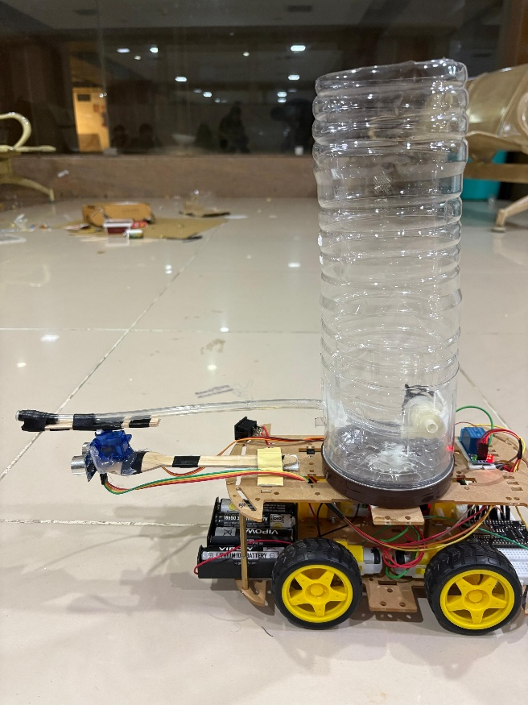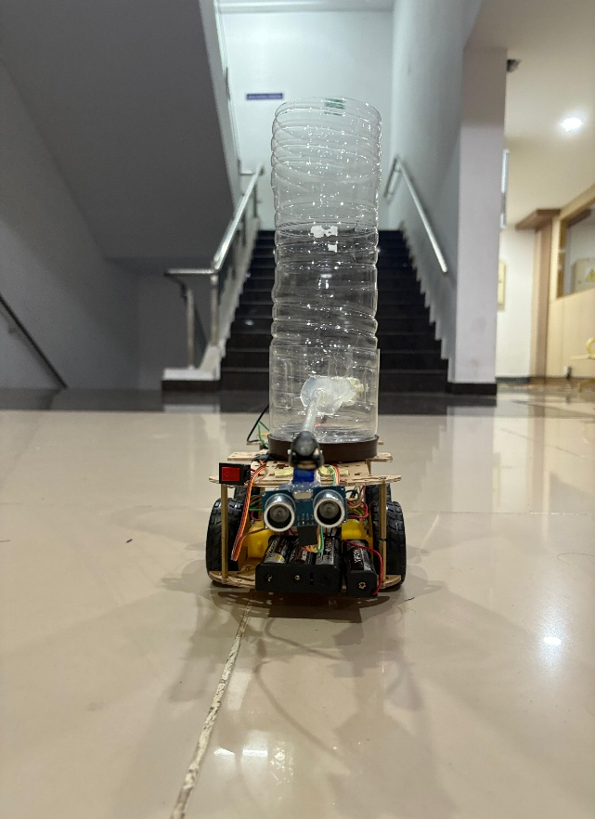

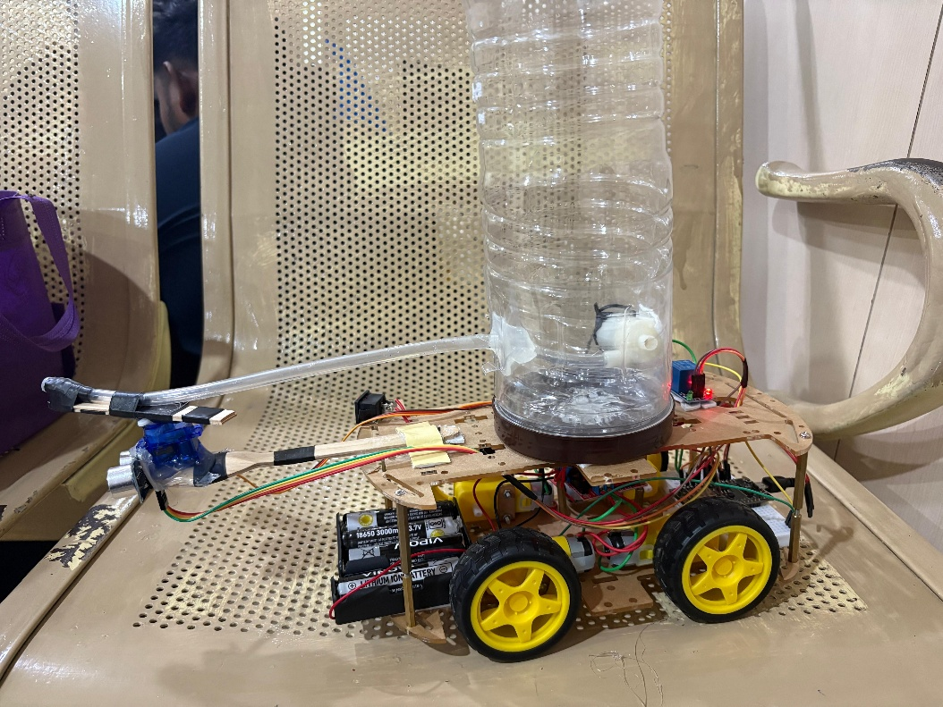

5.2 Software Implementation
The software part involves writing and uploading code to the ESP8266 using the Arduino IDE. The code includes functions for motor control, servo angle adjustment, and pump operation based on commands received from the Blynk application. Each movement direction and spraying action is assigned to specific digital pins on the NodeMCU.
The Blynk IoT app is configured on a smartphone to serve as the remote control interface. Buttons are added in the app to correspond to different actions such as forward, backward, left, right, and spray. When a button is pressed, a signal is transmitted via Wi-Fi to the ESP8266, which processes the input and triggers the respective hardware component.

Code:

/*************************************************************
Project: ESP8266 Blynk Wi-Fi Robot (Motors + Pump + Servo + Ultrasonic safety)
Hardware: NodeMCU + L298N + Relay + Servo + HC-SR04
Author: Ish
Notes: TRIG = D3, ECHO = D2. Uses V8 for distance (cm) and V10 for status messages.
*************************************************************/

// --- Blynk Template Info ---
#define BLYNK_TEMPLATE_ID "TMPL3U2rGpfY7"
#define BLYNK_TEMPLATE_NAME "WiFi Robot"
#define BLYNK_AUTH_TOKEN "Y-O90VmQklqC9eoBadBmNUn-bP7hWER8"

// --- Libraries ---
#include <ESP8266WiFi.h>
#include <BlynkSimpleEsp8266.h>
#include <Servo.h>

// --- Wi-Fi Credentials ---
char ssid[] = "KaranIphone";
char pass[] = "karan123";

// --- Motor Driver Pins (L298N) ---
#define IN1 D5
#define IN2 D6
#define IN3 D7
#define IN4 D8

// --- Relay Pin for Pump ---
#define RELAY_PIN D4

// --- Servo Pin ---
#define SERVO_PIN D1 // NodeMCU D1 (GPIO5)

// --- Ultrasonic Pins ---
#define TRIG_PIN D3 // NodeMCU D3 (GPIO0)
#define ECHO_PIN D2 // NodeMCU D2 (GPIO4)

// --- Ultrasonic conversion ---
#define SOUND_VELOCITY 0.034 // cm per microsecond

// --- Virtual Pins ---
#define VFORWARD V1
#define VBACKWARD V2
#define VLEFT V3
#define VRIGHT V4
#define VSTOP V5
#define VPUMP V6
#define VSERVO V7
#define VDIST_CM V8 // Distance (cm)
#define VSTATUS V10 // Status messages

// --- Safety threshold ---
const float STOP_LEFT_THRESH = 40.0; // Left blocked ≤ 40 cm

BlynkTimer timer;
Servo servo;
bool leftBlocked = false; // left-block flag

// --- Movement helper functions ---
void moveForward() { digitalWrite(IN1, HIGH); digitalWrite(IN2, LOW); digitalWrite(IN3, HIGH); digitalWrite(IN4, LOW); }
void moveBackward() { digitalWrite(IN1, LOW); digitalWrite(IN2, HIGH); digitalWrite(IN3, LOW); digitalWrite(IN4, HIGH); }
void turnLeft() { digitalWrite(IN1, LOW); digitalWrite(IN2, HIGH); digitalWrite(IN3, HIGH); digitalWrite(IN4, LOW); }
void turnRight() { digitalWrite(IN1, HIGH); digitalWrite(IN2, LOW); digitalWrite(IN3, LOW); digitalWrite(IN4, HIGH); }
void stopMotors() { digitalWrite(IN1, LOW); digitalWrite(IN2, LOW); digitalWrite(IN3, LOW); digitalWrite(IN4, LOW); }

// --- Blynk movement handlers ---
BLYNK_WRITE(VFORWARD) { if (param.asInt()) moveForward(); else stopMotors(); }
BLYNK_WRITE(VBACKWARD) { if (param.asInt()) moveBackward(); else stopMotors(); }

BLYNK_WRITE(VLEFT) {
if (param.asInt()) {
if (!leftBlocked) turnLeft();
else {
stopMotors();
Blynk.virtualWrite(VSTATUS, "⛔ Left blocked (obstacle ≤ 40 cm)");
}
} else stopMotors();
}

BLYNK_WRITE(VRIGHT) { if (param.asInt()) turnRight(); else stopMotors(); }
BLYNK_WRITE(VSTOP) { if (param.asInt()) stopMotors(); }

// --- Pump (Relay) ---
BLYNK_WRITE(VPUMP) {
int pumpState = param.asInt();
digitalWrite(RELAY_PIN, pumpState ? HIGH : LOW);
Serial.println(pumpState ? "Pump ON" : "Pump OFF");
Blynk.virtualWrite(VSTATUS, pumpState ? "Pump ON" : "Pump OFF");
}

// --- Servo ---
BLYNK_WRITE(VSERVO) {
int pos = constrain(param.asInt(), 0, 180);
servo.write(pos);
Serial.print("Servo moved to: ");
Serial.println(pos);
Blynk.virtualWrite(VSTATUS, String("Servo: ") + pos);
}

// --- Ultrasonic measurement + left-stop logic ---
void sendDistanceToBlynk() {
// Trigger pulse
digitalWrite(TRIG_PIN, LOW);
delayMicroseconds(2);
digitalWrite(TRIG_PIN, HIGH);
delayMicroseconds(10);
digitalWrite(TRIG_PIN, LOW);

// Measure echo
unsigned long duration = pulseIn(ECHO_PIN, HIGH, 30000);
float distanceCm = -1.0;

if (duration == 0) {
distanceCm = -1.0;
Serial.println("Distance: out of range");
Blynk.virtualWrite(VDIST_CM, 0);
Blynk.virtualWrite(VSTATUS, "Distance: out of range");
return;
}

distanceCm = (duration * SOUND_VELOCITY) / 2.0;
Serial.print("Distance (cm): ");
Serial.println(distanceCm, 2);
// Send to Blynk
Blynk.virtualWrite(VDIST_CM, distanceCm);
Blynk.virtualWrite(VSTATUS, String("Distance: ") + String(distanceCm, 2) + " cm");

// --- Left stop logic ---
if (distanceCm <= STOP_LEFT_THRESH) {
if (!leftBlocked) {
leftBlocked = true;
stopMotors();
Serial.println("🚨 Forward BLOCKED: Obstacle ≤ 40 cm");
Blynk.virtualWrite(VSTATUS, "🚨 Forward BLOCKED: Obstacle ≤ 40 cm");
}
} else {
if (leftBlocked) {
leftBlocked = false;
Serial.println("✅ Safe: Forward motion allowed (>40 cm)");
Blynk.virtualWrite(VSTATUS, "✅ Safe: Forward motion allowed (>40 cm)");
}
}
}

// --- Setup ---
void setup() {
Serial.setDebugOutput(false);
Serial.begin(115200);
delay(100);

Serial.println("Connecting to Wi-Fi...");
WiFi.begin(ssid, pass);
while (WiFi.status() != WL_CONNECTED) {
delay(500);
Serial.print(".");
}
Serial.println();
Serial.print("Wi-Fi connected! IP: ");
Serial.println(WiFi.localIP());

Serial.println("Connecting to Blynk...");
Blynk.begin(BLYNK_AUTH_TOKEN, ssid, pass);

// Initialize pins
pinMode(IN1, OUTPUT);
pinMode(IN2, OUTPUT);
pinMode(IN3, OUTPUT);
pinMode(IN4, OUTPUT);

pinMode(RELAY_PIN, OUTPUT);
digitalWrite(RELAY_PIN, LOW);

pinMode(TRIG_PIN, OUTPUT);
pinMode(ECHO_PIN, INPUT);

servo.attach(SERVO_PIN);
servo.write(90);

stopMotors();
Serial.println("Setup complete. Ready!");

// Ultrasonic update every 1 sec
timer.setInterval(1000L, sendDistanceToBlynk);
}

// --- Loop ---
void loop() {
Blynk.run();
timer.run();
}

5.3 Communication Setup
Wireless communication is established through the Blynk IoT platform. The ESP8266 is connected to a Wi-Fi network and linked to the Blynk project using authentication tokens. Real-time commands are transmitted from the mobile app to the microcontroller with minimal delay, ensuring instant response. This communication allows the user to control the robot’s motion and spraying system from a safe distance, preventing direct pesticide exposure.

OUTPUT
BLYNK CONSOLE

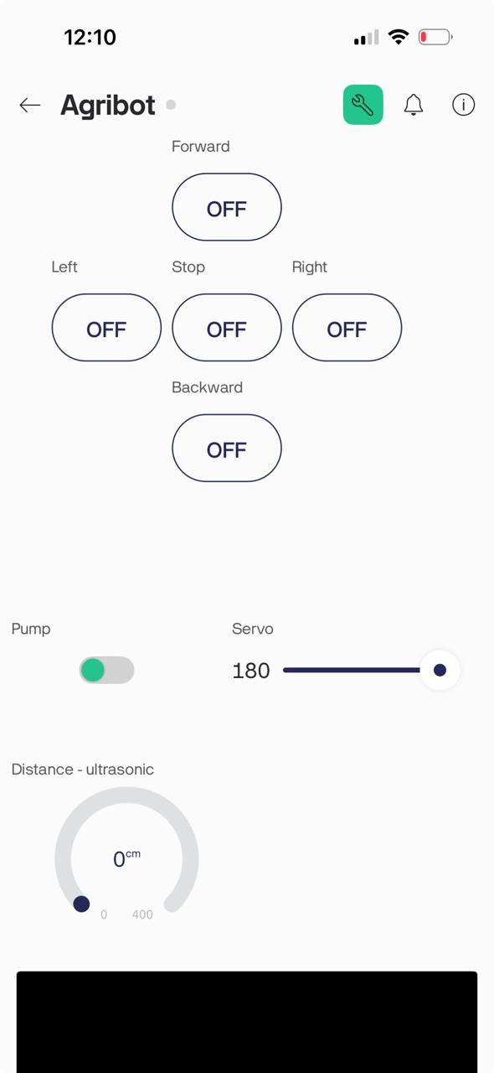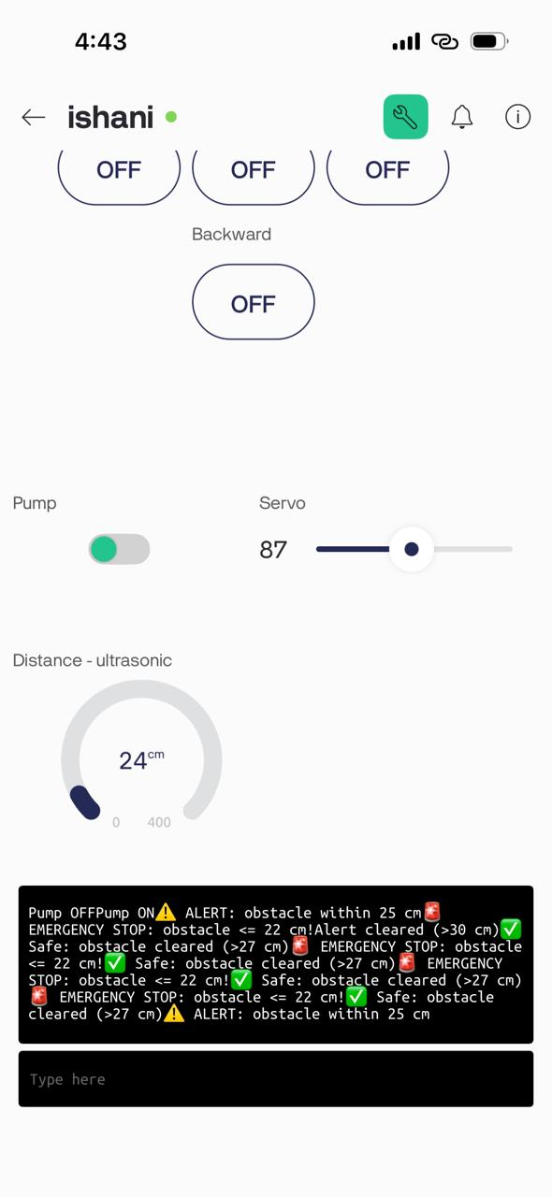

CHAPTER 6

EXPERIMENTAL RESULTS AND ANALYSIS

Usability Evaluation

The Agribot – Pesticide Spraying Robot was tested in a controlled agricultural environment to evaluate its usability and ease of operation. The system was found to be highly user-friendly, requiring minimal technical knowledge to operate. The Blynk IoT mobile application provided an intuitive interface that allowed smooth control of the robot’s movements and spraying functions through simple touch commands. Farmers and users could easily connect the robot to Wi-Fi and operate it remotely without physical contact with pesticides. The compact design and portability made it convenient for use in small and medium-sized farms. Overall, the system demonstrated practical usability and reliable performance in real-field conditions.

User Satisfaction Survey

A small group of students were invited to operate the Agribot and provide feedback. The survey results indicated a high level of satisfaction in terms of system operation, control accuracy, and safety. Users appreciated the wireless control feature that eliminated direct pesticide exposure. Most participants agreed that the robot reduced physical strain and saved time compared to manual spraying methods. Feedback also highlighted the affordability and simplicity of the system as major advantages. Suggestions included adding features like automatic path control and battery status indicators in future versions. The positive responses confirmed that the system successfully met its primary goals of safety, efficiency, and ease of use.

System Performance Evaluation

The system’s performance was evaluated based on parameters such as response time, spraying uniformity, mobility, and power efficiency. The robot responded to Blynk app commands almost instantaneously, with negligible delay in Wi-Fi communication. The motor driver and BO motors provided stable movement on moderately uneven surfaces. The relay-controlled pump sprayed pesticide evenly with consistent pressure, and the servo motors accurately adjusted nozzle angles for uniform coverage. The rechargeable battery powered the robot continuously for more than one hour, indicating good energy efficiency. The overall system performed reliably in multiple test cycles without malfunction, demonstrating strong operational stability and practical field readiness.

Data Collection and Analysis

Data were collected during several test runs to analyze spraying consistency, coverage area, and operating duration. Observations showed that the robot maintained a uniform spray pattern and covered approximately 20–25 square meters per tank refill under standard field conditions. The Wi-Fi connection remained stable within a range of up to 30 meters from the control device. The power consumption analysis revealed that the pump and motors were the main energy consumers, yet the system maintained adequate battery performance throughout the trials. From the collected data, it was evident that the Agribot achieved its objectives of minimizing human effort, ensuring even pesticide distribution, and enhancing overall spraying efficiency.

CHAPTER 7

CONCLUSION

Through this project, we gained practical experience in designing and implementing an IoT-based robotic system for agricultural automation. We learned to integrate hardware components such as the ESP8266 NodeMCU, motor drivers, pumps, and sensors with the Blynk IoT platform to achieve wireless control and automation. The project helped us understand real-time data communication, circuit interfacing, and mobile app-based control of electromechanical systems. Additionally, we developed skills in system calibration, testing, and troubleshooting to ensure reliable spraying performance and mobility in real field conditions.

The Agribot – Pesticide Spraying Robot successfully demonstrates how automation and IoT technology can enhance agricultural practices while ensuring farmer safety and efficiency. The project minimizes human exposure to harmful pesticides through a Wi-Fi-controlled robotic platform with remote spraying capability. Integration of affordable components like BO motors, a DC pump, and servo motors makes it cost-effective and accessible for small-scale farmers, while its lightweight design ensures ease of use and maintenance. Overall, the Agribot provides a safe, efficient, and low-cost alternative to manual spraying, showcasing the potential of IoT and robotics to promote smart, sustainable farming practices.

CHAPTER 8

FUTURE SCOPE

1.Integration of Camera Module: The Agribot can be enhanced with a high-resolution camera module to capture real-time images of crops, enabling visual monitoring and supporting computer vision-based detection of weeds, pests, and affected areas for precise and targeted spraying.
2. Plant Health Monitoring: By incorporating image processing and sensor data analysis, the robot can assess plant health indicators such as leaf color, moisture level, and pest damage, allowing early detection of crop stress and smarter pesticide management for improved yield and sustainability.

CHAPTER 9

REFERENCES

- Prathibha, S. R., Hongal, A., & Jyothi, M. P. (2017). “IOT Based Monitoring System in Smart Agriculture.” International Conference on Recent Advances in Electronics and Communication Technology (ICRAECT), IEEE.
- Ramesh, M. V., & Manjunatha, N. (2020). “IoT Enabled Smart Agriculture for Pesticide Spraying and Crop Monitoring.” International Journal of Scientific Research in Engineering and Management (IJSREM), Vol. 4, Issue 3.
- Sharma, A., Singh, R., & Bhatia, R. (2019). “Design and Development of Smart Pesticide Spraying Robot.” International Journal of Innovative Technology and Exploring Engineering (IJITEE), Vol. 8, Issue 7.
- Raj, P., & Anandan, P. (2021). “Automation in Agriculture using IoT and Embedded Systems.” Journal of Emerging Technologies and Innovative Research (JETIR), Vol. 8, Issue 5.
- Kumar, V., & Gupta, S. (2020). “Wi-Fi Controlled Multi-Purpose Agricultural Robot.” International Journal of Advanced Research in Electronics and Communication Engineering (IJARECE), Vol. 9, Issue 8.
- Gokul, R., & Karthick, M. (2022). “Development of IoT Based Smart Spraying Robot for Pesticide Application.” International Journal of Engineering Research & Technology (IJERT), Vol. 11, Issue 6.
- Divya, K., & Sanjay, M. (2021). “Low-Cost Automation in Agriculture Using NodeMCU and Blynk IoT.” International Research Journal of Engineering and Technology (IRJET), Vol. 8, Issue 10.
- Khosla, R., & Singh, S. (2022). “Precision Agriculture and Role of IoT in Crop Management.” International Journal of Computer Science and Information Security (IJCSIS), Vol. 20, Issue 4.
- Mehta, D., & Patel, J. (2023). “IoT-Based Robotic System for Safe and Efficient Pesticide Spraying.” International Journal of Research in Engineering and Technology (IJRET), Vol. 12, Issue 2.
- Srivastava, P., & Choudhary, A. (2021). “Design and Implementation of Smart Agricultural Robot Using ESP8266.” International Journal of Science and Research (IJSR), Vol. 10, Issue 11.

